Weighted

⚖️ What Is Weighted Load Balancing?
# Source: AI Source: Provided by: [Data Path: Persons Table -> ID Column: 1, Name_En Column: Motasem Essam] -> From: [ChatGPT] on [12/15/2025]
Weighted load balancing is a method where each server is assigned a weight, and the load balancer distributes traffic based on those weights.
Servers with higher weights receive more requests because they are more powerful or have higher capacity.

✅ Simple Definition:
# Source: AI Source: Provided by: [Data Path: Persons Table -> ID Column: 1, Name_En Column: Motasem Essam] -> From: [ChatGPT] on [12/15/2025]
In weighted balancing, servers with higher "importance" (weight) get more requests than those with lower weight.

🧠 Real-Life Analogy:
# Source: AI Source: Provided by: [Data Path: Persons Table -> ID Column: 1, Name_En Column: Motasem Essam] -> From: [ChatGPT] on [12/15/2025]
Think of a factory with 3 workers:
- Worker A is fast → gets 6 tasks
- Worker B is average → gets 3 tasks
- Worker C is slow → gets 1 task
The manager distributes jobs based on ability — that’s weighted load balancing.

📊 Example: Weight Distribution
# Source: AI Source: Provided by: [Data Path: Persons Table -> ID Column: 1, Name_En Column: Motasem Essam] -> From: [ChatGPT] on [12/15/2025]
Let’s say you have 3 servers:
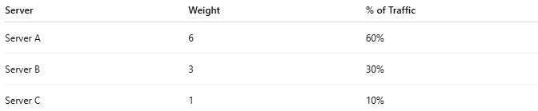

Server | Weight | % of Traffic
Server A | 6 | 60%
Server B | 3 | 30%
Server C | 1 | 10%
Incoming requests will be split roughly in that ratio.

🧱 Nginx Example Configuration:
# Source: AI Source: Provided by: [Data Path: Persons Table -> ID Column: 1, Name_En Column: Motasem Essam] -> From: [ChatGPT] on [12/15/2025]

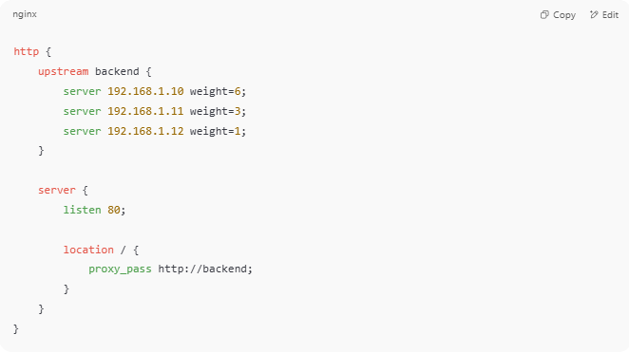
http {
upstream backend {
server 192.168.1.10 weight=6;
server 192.168.1.11 weight=3;
server 192.168.1.12 weight=1;
}

server {
listen 80;

location / {
proxy_pass http://backend;
}
}
}

🚀 In this example:
- Server A will get 6 out of every 10 requests
- Server B will get 3
- Server C will get 1

✅ Benefits of Weighted Load Balancing
# Source: AI Source: Provided by: [Data Path: Persons Table -> ID Column: 1, Name_En Column: Motasem Essam] -> From: [ChatGPT] on [12/15/2025]
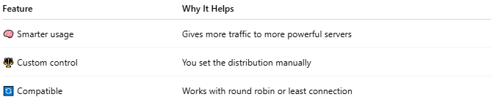

Feature | Why It Helps
🧠 Smarter usage | Gives more traffic to more powerful servers
⚖️ Custom control | You set the distribution manually
🔄 Compatible | Works with round robin or least connection

⚠️ Limitations
# Source: AI Source: Provided by: [Data Path: Persons Table -> ID Column: 1, Name_En Column: Motasem Essam] -> From: [ChatGPT] on [12/15/2025]
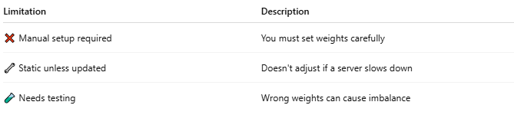

Limitation | Description
❌ Manual setup required | You must set weights carefully
🔧 Static unless updated | Doesn't adjust if a server slows down
🧪 Needs testing | Wrong weights can cause imbalance

🔁 When to Use Weighted Balancing
# Source: AI Source: Provided by: [Data Path: Persons Table -> ID Column: 1, Name_En Column: Motasem Essam] -> From: [ChatGPT] on [12/15/2025]
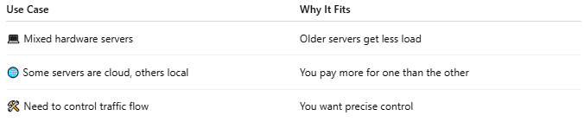

Use Case | Why It Fits
💻 Mixed hardware servers | Older servers get less load
🌐 Some servers are cloud, others local | You pay more for one than the other
🛠 Need to control traffic flow | You want precise control

🔄 Works With These Strategies:
# Source: AI Source: Provided by: [Data Path: Persons Table -> ID Column: 1, Name_En Column: Motasem Essam] -> From: [ChatGPT] on [12/15/2025]
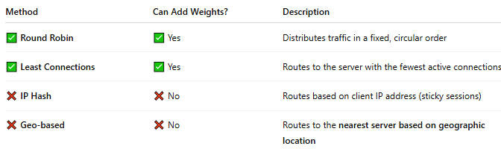
Method | Can Add Weights? | Description
✅ Round Robin | ✅ Yes | Distributes traffic in a fixed, circular order
✅ Least Connections | ✅ Yes | Routes to the server with the fewest active connections
❌ IP Hash | ❌ No | Routes based on client IP address (sticky sessions)
❌ Geo-based | ❌ No | Routes to the nearest server based on geographic location

📌 Summary
# Source: AI Source: Provided by: [Data Path: Persons Table -> ID Column: 1, Name_En Column: Motasem Essam] -> From: [ChatGPT] on [12/15/2025]
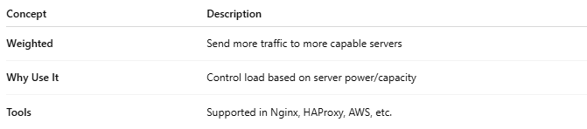

Concept | Description
Weighted | Send more traffic to more capable servers
Why Use It | Control load based on server power/capacity
Tools | Supported in Nginx, HAProxy, AWS, etc.

